1.what is devops
DevOps is a cultural philosophy and set of technical practices that unifies software development (Dev) and IT operations (Ops). It breaks down traditional silos to automate and accelerate the software delivery lifecycle, enabling teams to release applications and updates faster, more reliably, and with higher quality. [1, 2, 3, 4, 5]
Objectives of DevOps
- Improve collaboration between development and operations teams.
- Automate software development and deployment processes.
- Deliver software faster and more frequently.
- Ensure reliable and stable releases.
- Continuously monitor and improve applications.
DevOps Lifecycle
- Plan
- Develop
- Build
- Test
- Release
- Deploy
- Operate
- Monitor
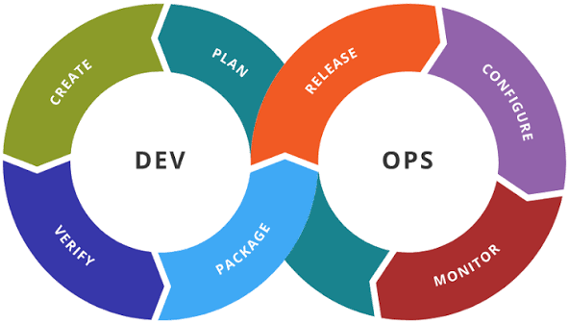
Common DevOps Tools
- Version Control - Git, GitHub
- Continuous Integration - Jenkins, GitHub Actions
- Build Tools - Maven, Gradle
- Containerization - Docker
- Container Orchestration - Kubernetes
- Configuration Management - Ansible, Puppet
- Cloud Platforms - Microsoft Azure, AWS, Google Cloud
- Monitoring - Prometheus, Grafana

2. Advantages of DevOps
1. Faster Software Delivery
- Automates development and deployment, reducing release time.
2. Better Collaboration
- Developers and operations teams work together throughout the project.
3. Continuous Integration and Continuous Deployment (CI/CD)
- Code changes are automatically tested and deployed.
4. Improved Software Quality
- Automated testing helps identify bugs early.
5. Reduced Deployment Failures
- Smaller and frequent releases minimize risks.
6. Faster Bug Fixes
- Issues are detected and resolved quickly through monitoring.
7. Increased Productivity
- Automation reduces repetitive manual tasks.
8. Better Customer Satisfaction
- New features and fixes reach users more quickly.
9. Scalability
- Applications can easily scale based on user demand.
10. Continuous Monitoring
- Helps detect issues before they impact users.

3. What is Agile Methodology?
Agile is a software development methodology that focuses on delivering software in small, incremental iterations instead of completing the entire project at once.
It encourages:
- Customer collaboration
- Continuous feedback
- Frequent software releases
- Flexibility to changing requirements
- Team collaboration
Agile Principles
- Deliver working software frequently.
- Welcome changing requirements.
- Collaborate closely with customers.
- Focus on customer satisfaction.
- Improve continuously through feedback.
Agile Process
- Requirement Gathering
- Planning
- Design
- Development
- Testing
- Review
- Deployment
- Feedback
- Repeat the cycle
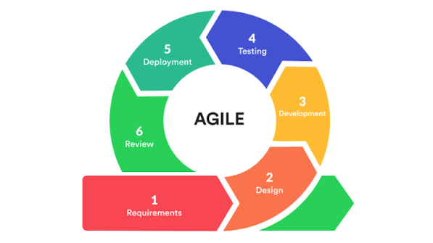
What is Scrum?
Scrum is the most popular Agile framework used to manage software development projects.
It divides the project into short development cycles called Sprints.
Sprint
- Duration: 1–4 weeks
- Goal: Deliver a working product increment at the end of each sprint.
Scrum Roles
1. Product Owner
- Defines product requirements.
- Maintains the Product Backlog.
- Prioritizes work.
- Represents customer needs.
2. Scrum Master
- Ensures Scrum practices are followed.
- Removes obstacles for the team.
- Facilitates Scrum meetings.
- Supports team productivity.
3. Development Team
- Designs, develops, tests, and delivers the product.
- Works collaboratively to complete sprint goals.
Scrum Artifacts
- Product Backlog
- Sprint Backlog
- Increment
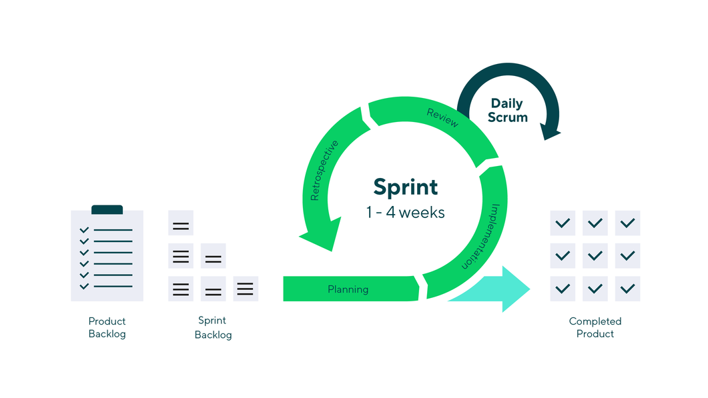
4. Important Meetings in Agile (Scrum Events)
1. Sprint Planning Meeting
Purpose
- Plan the work for the upcoming sprint.
Participants
- Product Owner
- Scrum Master
- Development Team
Outcome
- Sprint Goal
- Sprint Backlog
2. Daily Scrum (Daily Stand-up)
Purpose
- Track daily progress.
Duration
- 15 minutes.
Each team member answers:
- What did I complete yesterday?
- What will I work on today?
- Are there any blockers?
3. Sprint Review Meeting
Purpose
- Demonstrate the completed work to stakeholders.
- Collect feedback.
Outcome
- Product improvements.
- Updated Product Backlog.

4. Sprint Retrospective
Purpose
- Review how the team worked during the sprint.
- Identify improvements for the next sprint.
Discussion
- What went well?
- What did not go well?
- What can be improved?

5. Backlog Refinement (Backlog Grooming)
Purpose
- Review and prioritize Product Backlog items.
- Clarify requirements.
- Estimate upcoming work.
Outcome
- Well-prepared backlog for future sprints.

5. Advantages of Agile
1. Faster Delivery
- Software is delivered in small increments.
2. Better Customer Satisfaction
- Customers provide regular feedback, ensuring the product meets their expectations.
3. Flexibility
- Easily adapts to changing business requirements.
4. Improved Product Quality
- Continuous testing and frequent reviews improve quality.
5. Better Team Collaboration
- Daily communication keeps everyone aligned.
6. Early Risk Identification
- Problems are detected and resolved early.
7. Increased Transparency
- Stakeholders can track project progress throughout development.
8. Continuous Improvement
- Teams enhance their processes after each sprint through retrospectives.
9. Reduced Project Risk
- Frequent releases make issues easier to identify and fix.

